Luke Incorvaia

1. 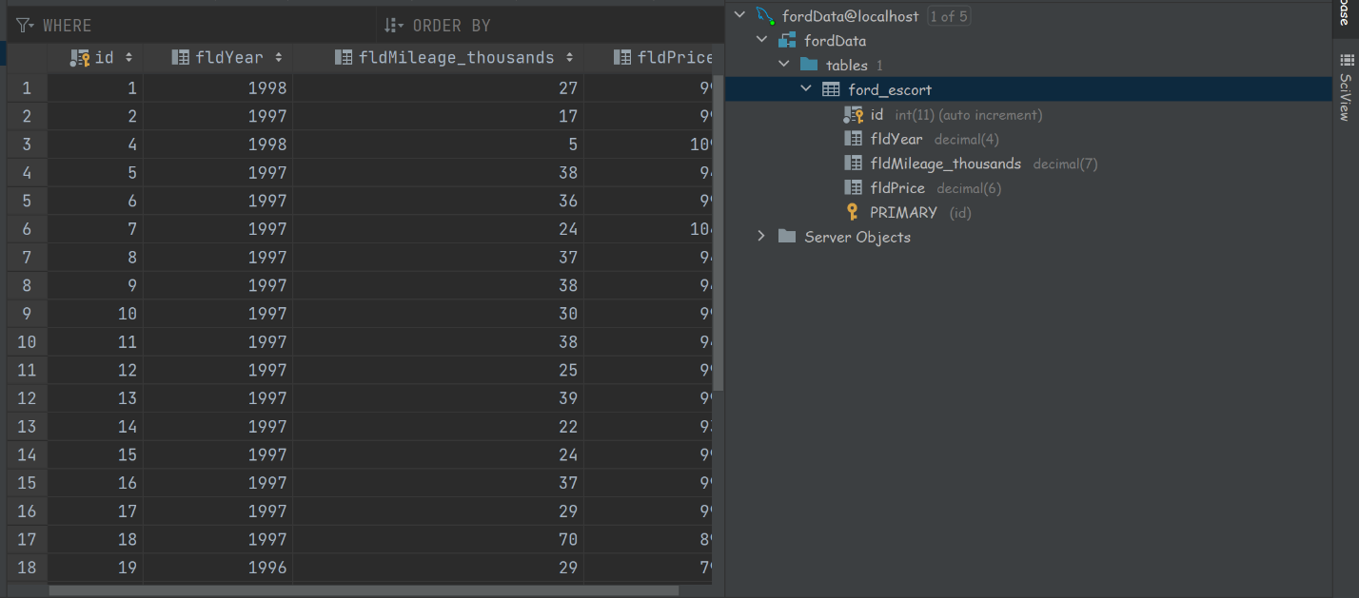The project showing that you can view YOUR data tables in pycharm
2. . YOUR project running correctly in the browser displaying your homepage with your data

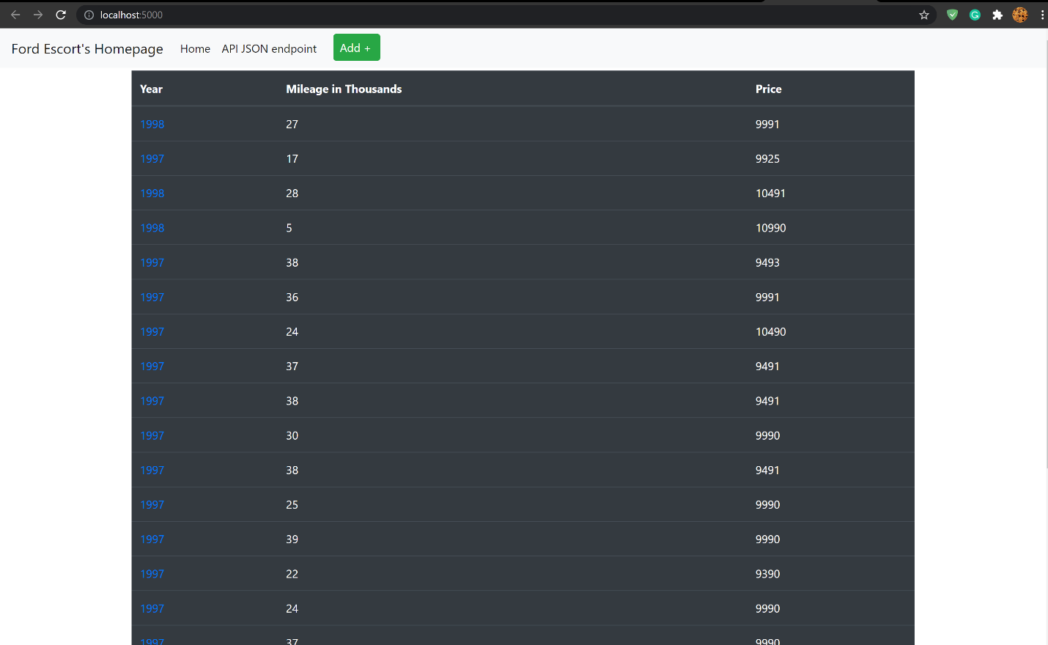

1. YOUR project running correctly in the browser displaying your data record as a view of one record

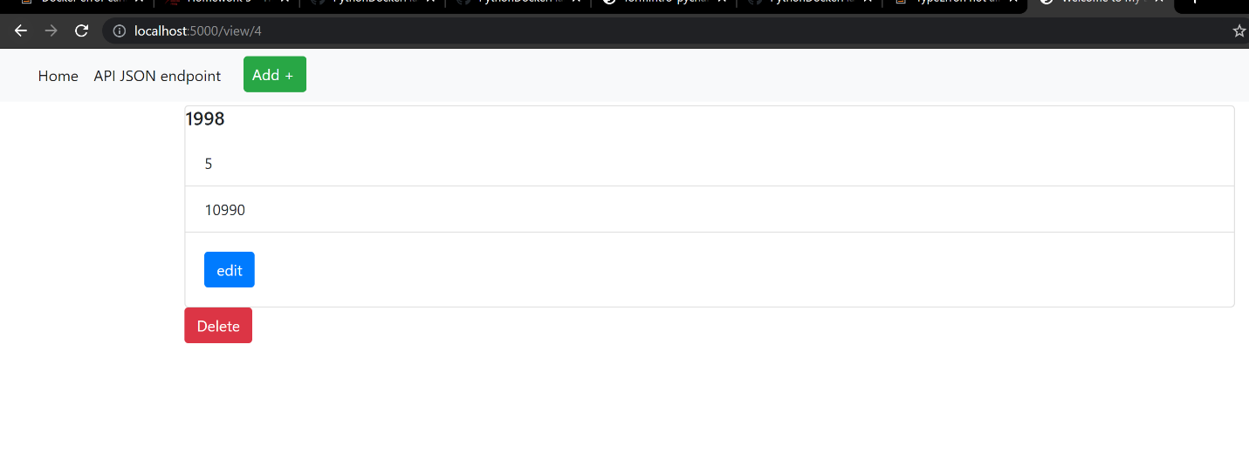

1. YOUR project running correctly in the browser displaying a new record added to your home page

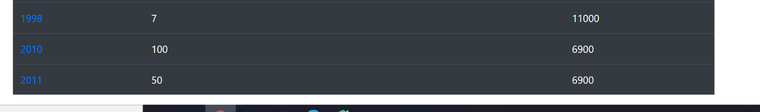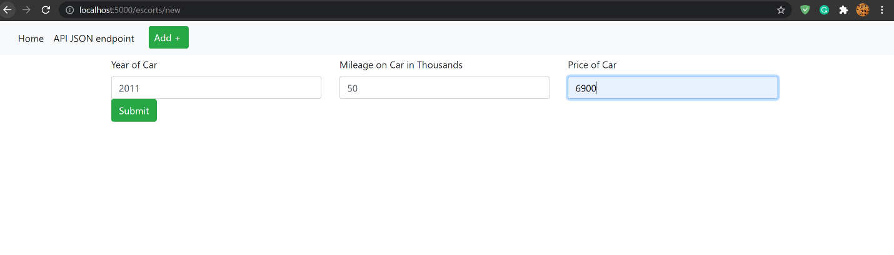The Information of the new data entry

The new data entry in the table

1. YOUR project running correctly in the browser displaying an updated record added to your home page

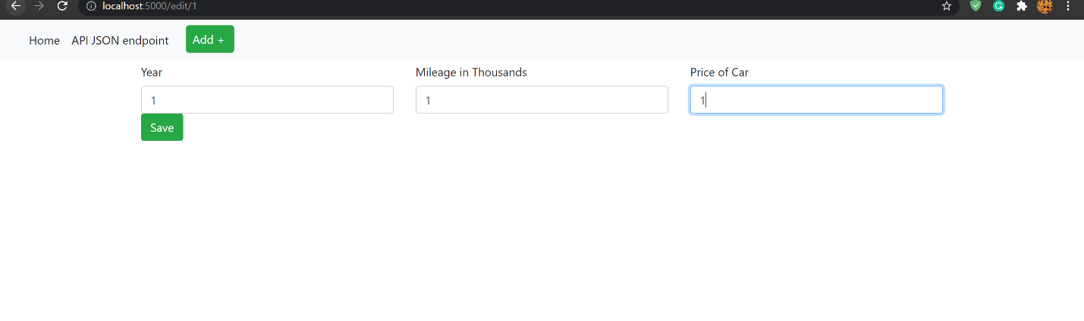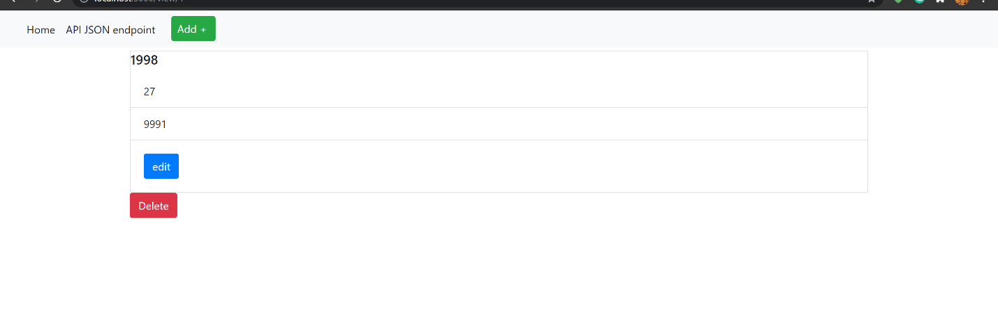The data entry that will be edited

The new info for the entry

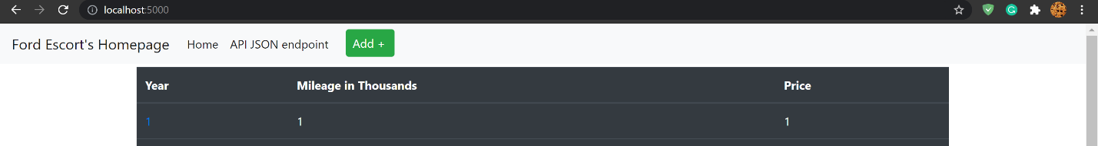

Updated entry in the data table

1. YOUR project running correctly in the browser displaying a deleted record added to your home page

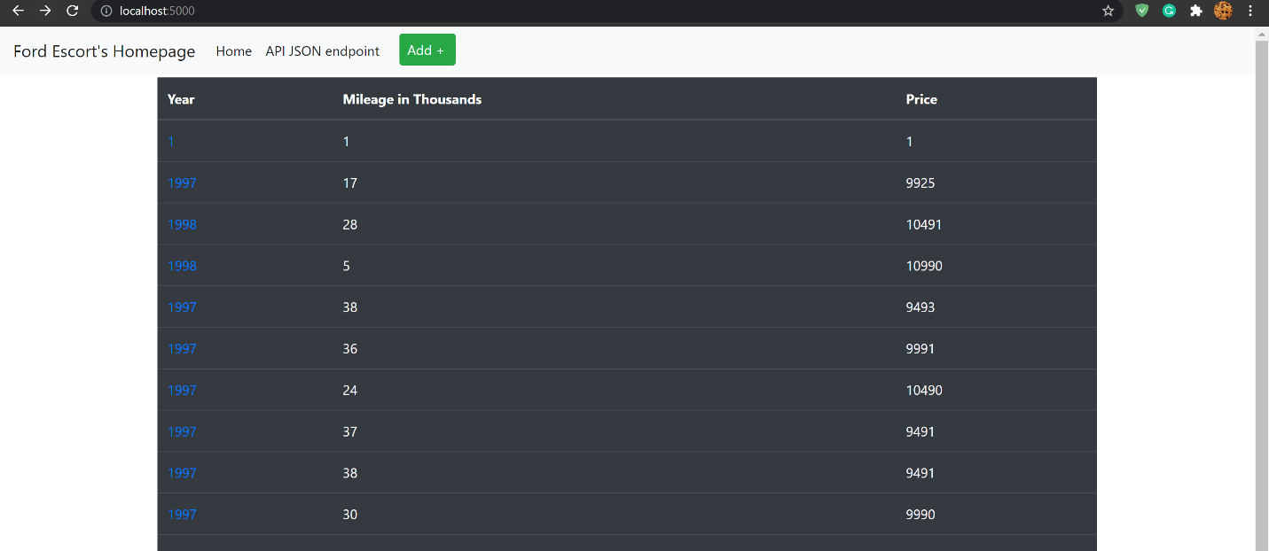

The table before deletion

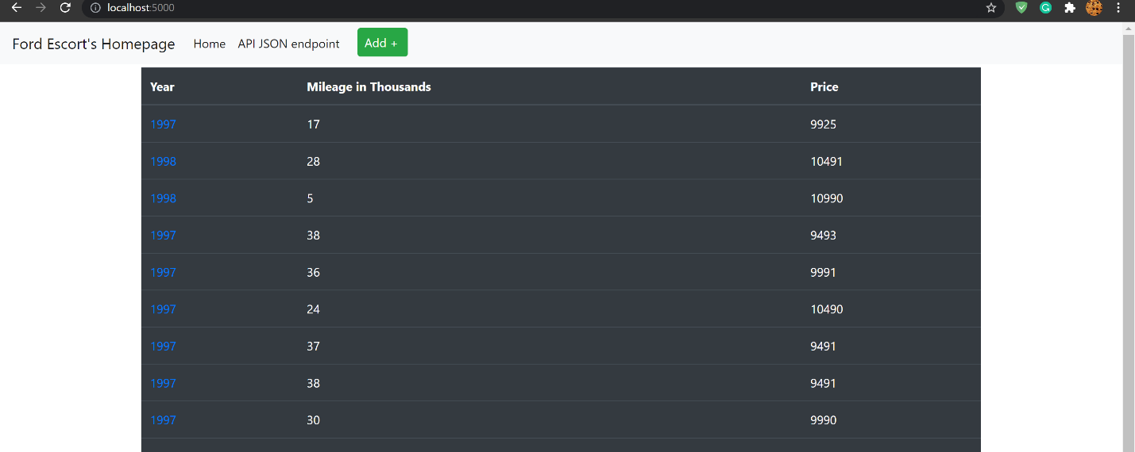

The table after deletion (the top one was removed)